### Assured Contract Farming System for Stable Market Access

### A PROJECT REPORT

***Submitted by***

**DUGASANI MEGHANA - 20211CAI0023**

**VENKATA SAI MEGHANA - 20211CAI0048**

**VIJAYA KUMARI - 20211CAI0012**

**HRUSHIKESH REDDY - 20211CAI0022**

**SUNIL KUMAR REDDY - 20211CAI0053**

### *Under the guidance of*

**Dr. SASIDHAR BABU SUVANAM**

***in partial fulfillment for the award of the degree of***

**BACHELOR OF TECHNOLOGY**

**IN**

**COMPUTER SCIENCE AND ENGINEERING**

**(ARTIFICIAL INTELLIGENCE AND MACHINE LEARNING)**



# PRESIDENCY UNIVERSITY BENGALURU

**May 2025**

# CHAPTER-1 INTRODUCTION

Agriculture continues to serve as the backbone of many economies, particularly in developing countries where a large portion of the population relies on farming as a primary source of livelihood. Despite its significance, the agricultural sector is plagued by several long-standing challenges such as unpredictable market conditions, lack of direct buyer access, price fluctuations, and exploitation by intermediaries. These challenges often result in income instability for farmers, discouraging investment in better inputs, innovation, and sustainable farming practices. The absence of a structured and reliable marketing framework leaves farmers uncertain about the sale of their produce, leading to economic vulnerability and social distress.

One proven approach to countering these issues is **contract farming**, a pre-agreed arrangement between farmers and buyers that ensures the purchase of agricultural produce under predetermined conditions. This model helps farmers secure a fixed price and assured buyer in advance, which significantly reduces the risks associated with traditional open-market sales. However, traditional contract farming systems are often manual, paper-based, fragmented, and susceptible to manipulation or disputes due to lack of transparency and standardization. To make contract farming more efficient, accessible, and reliable, there is a pressing need for a digital platform that simplifies and safeguards the entire process.

This project proposes the development of an **Assured Contract Farming System**, a comprehensive web-based platform that digitally connects farmers with institutional buyers such as retailers, wholesalers, food processors, exporters, and government procurement agencies. The system is designed to facilitate transparent contract creation, negotiation, and enforcement, ensuring a structured buying process that benefits both parties. It allows farmers to list available crops, set timelines and conditions, and accept or negotiate proposals from buyers. Once both parties agree on terms, a digital contract is generated and stored securely. In addition, the platform integrates a secure payment gateway to facilitate timely and transparent transactions and reduces the risk of payment default.

Beyond basic contract facilitation, the platform offers features such as user registration and verification, automated reminders for deliveries and payments, a digital dashboard for monitoring contracts, a feedback and rating system to build trust, and a dispute resolution mechanism to handle grievances. It is developed using modern technologies such as **Next.js** for the frontend, **Firebase** for authentication and database management, and popular **payment gateways** like Stripe or Razorpay for transaction handling.

By digitizing and simplifying the contract farming process, the proposed system empowers farmers with market predictability, promotes fair trade, and enhances income security. Simultaneously, it helps buyers establish dependable supply chains with verified producers and traceable transactions. Ultimately, this project aims to bridge the gap between agricultural producers and the market by building a digital infrastructure that ensures fairness, transparency, and sustainability in contract farming.

# CHAPTER-2 LITERATURE SURVEY

**Title:** Smart Contract-Based Blockchain-Envisioned Authentication Scheme for Smart Farming.

In the paper titled *"Smart Contract-Based Blockchain-Envisioned Authentication Scheme for Smart Farming"*, the authors Anusha Vangala (IIIT Hyderabad), Anil Kumar Sutrala (CA Technologies, Hyderabad), Ashok Kumar Das (Senior Member, IEEE, IIIT Hyderabad), and Minho Jo (Senior Member, IEEE, Korea University, South Korea) propose an advanced authentication framework specifically designed for smart farming applications. With the increasing use of IoT devices in agriculture, the need for secure, traceable, and tamper-proof communication has become essential. This work addresses these challenges through a hybrid blockchain-based architecture that supports decentralized and trustworthy interactions among smart farming devices. It incorporates two key authentication mechanisms: Device-to-Device (D2D) for secure communication between IoT devices, and Device-to-Gateway (D2G) for reliable data transfer to gateway nodes. Smart contracts are utilized to achieve decentralized consensus, with edge servers processing data into blockchain blocks, which are then verified and stored in a cloud-based peer-to-peer (P2P) network.

The proposed scheme was evaluated using both formal and informal security analyses, simulations on a blockchain platform, and performance testing with cryptographic tools like the MIRACL SDK. The results show that the system effectively defends against common cyberattacks such as replay and impersonation while delivering superior performance in terms of computation and communication overhead. By reducing reliance on centralized systems and ensuring data integrity and authenticity, the framework meets the real-world needs of smart farming environments. It enhances data reliability, strengthens user trust, and supports automation, making it a robust and scalable solution for the digitization and modernization of precision agriculture.

**Title:** Smart Contract-Based Blockchain-Envisioned Authentication Scheme for Smart Farming

In the paper titled *"Smart Contract-Based Blockchain-Envisioned Authentication Scheme for Smart Farming"*, the authors Malni Kumarathunga, Rodrigo N. Calheiros, and Athula Ginige from the School of Computing, Western Sydney University, present a conceptual framework called the Smart Agricultural Futures Market (SAFM). This blockchain-powered trading platform aims to address the challenges of trust, market inaccessibility, and financial exclusion faced by smallholder farmers. SAFM integrates blockchain technology, smart contracts, and social capital mechanisms to create a secure and equitable trading environment, enabling small-scale farmers to build reliable trading relationships even with unknown buyers. The core components of the system include smart contracts that act as self-enforcing digital agreements, an immutable blockchain ledger for transparent transaction tracking, and a social capital score, which is derived from a farmer’s transaction history and used as collateral to establish trust.

The SAFM platform provides several benefits to farmers, including pre-harvest financing through future harvest contracts that allow partial advance payments, MoM (Many-One-Many) market linkages that support bulk community-based trading for better pricing, and futures contracts to manage price volatility. The study emphasizes how SAFM tackles key issues like lack of access to competitive markets, absence of financial collateral, and exploitation by intermediaries. By aggregating trust through blockchain technology, the platform not only enhances market efficiency and fair trade but also opens the door for integrating additional agricultural services such as crop insurance, loans, and subsidy distribution.

### ****Title:**** Blockchain-Based Approach for Crop Index Insurance in Agricultural Supply Chain

### In the paper titled *"Blockchain-Based Approach for Crop Index Insurance in Agricultural Supply Chain"*, the authors Ilhaam A. Omar, Raja Jayaraman, and Mohammed Omar from Khalifa University of Science and Technology, UAE, along with Khaled Salah and Haya R. Hasan from the Department of Electrical Engineering, Khalifa University, and Jiju Antony from Newcastle Business School, Northumbria University, UK, propose a blockchain-powered solution to address the inefficiencies of traditional crop insurance systems. These systems, especially for smallholder farmers, are often hindered by high costs, lack of transparency, fraud, and delayed payouts. The proposed approach utilizes a private Ethereum blockchain, smart contracts for automatic policy enforcement, and decentralized storage for seamless data validation.

### Key innovations of the system include automated claim processing based on real-time, pre-verified weather data, such as drought or rainfall indicators. The use of blockchain ensures full transparency by recording all transactions on an immutable ledger, which helps build trust among farmers, insurers, and data providers. Additionally, the elimination of intermediaries results in lower operational costs, making the insurance accessible for low-income farmers. Smart contract logic also plays a critical role in fraud prevention by validating claims against independently collected environmental data. The system was successfully implemented and tested using Remix IDE and Ethereum, with security analysis proving its resilience to tampering and denial-of-service attacks. Overall, this research contributes a scalable, transparent, and cost-effective model to modernize agricultural insurance and better support farmers facing climate-related risks.

# CHAPTER-3

**RESEARCH GAPS OF EXISTING METHODS**

Despite the advancements made in digital platforms aimed at enhancing the efficiency of contract farming, there are several **unresolved research gaps** in the existing systems. These gaps pertain to **technological, economic, legal, and social challenges** that hinder the full potential of contract farming to address the needs of farmers, buyers, and other stakeholders. The following is a detailed analysis of the current gaps in existing methods, focusing on the technical shortcomings, operational inefficiencies, and challenges to scalability and inclusivity.

### ****3.1. Absence of Seamless End-to-End Digital Contracting****

One of the most glaring gaps in current contract farming methods is the lack of **end-to-end digital contract management**. Existing platforms typically only provide solutions for specific components of the contract process, such as market discovery or payment processing. However, they fail to integrate the entire contract life cycle, from creation and negotiation to monitoring and enforcement.

Many existing systems continue to depend on paper contracts or informal digital records, resulting in inefficient contract management, challenges in auditing, and increased risks of fraud or non-compliance. There is a pressing need for research on automating contract execution, incorporating features such as built-in reminders, compliance checks, and dynamic adjustments based on real-time market conditions. Addressing this gap is essential for developing a fully integrated digital experience that reduces manual intervention and lowers administrative costs.

**Potential Research Opportunity**: Developing a **blockchain-based contract management system** for agriculture that ensures transparent, secure, and auditable contract history could be an innovative solution.

### ****3.2. Limited Market Intelligence and Dynamic Pricing Tools****

Many current contract farming platforms provide basic **price lists** or **static contract terms** that do not account for **market volatility, supply chain disruptions**, or **regional price variations**. In highly dynamic agricultural markets, where the value of crops fluctuates due to demand shifts, climatic conditions, and other factors, such simplistic pricing mechanisms are inadequate.

Farmers often engage in contracts without access to accurate market demand forecasting, which can result in mispricing and undervaluation of their produce. Additionally, existing platforms lack mechanisms for real-time price adjustments, as they do not integrate current market trend data or support dynamic price renegotiation based on fluctuating conditions, limiting fair and responsive pricing strategies.

**Potential Research Opportunity**: Research into the use of **AI-driven predictive models** that incorporate **real-time supply chain data**, **global market trends**, and **weather forecasting** could create a dynamic pricing model that benefits both farmers and buyers.

### ****3.3. Inadequate Legal Framework and Dispute Resolution****

One of the biggest challenges in contract farming is the **lack of standardized legal frameworks** for digitally signed contracts. In the absence of proper legal enforceability and dispute resolution systems, farmers often feel insecure entering into digital contracts, especially when dealing with large, institutional buyers who may have more bargaining power.

Despite the digital storage of contract farming agreements, there is a lack of a standardized legal framework to verify and enforce these contracts in court or during disputes. Furthermore, most existing platforms do not provide clear mechanisms for dispute resolution or mediation, leaving farmers with limited legal recourse and vulnerable to exploitation or non-compliance by buyers.

**Potential Research Opportunity**: Integrating **smart contracts on blockchain** for agricultural transactions can provide automated enforcement mechanisms and **conflict resolution protocols**, making contracts legally binding and reducing risks for both parties.

### ****3.4. Lack of Transparent and Secure Payment Systems****

The existing systems for contract farming often **lack built-in financial safeguards**, leaving both farmers and buyers vulnerable to issues like delayed payments, fraud, or discrepancies in transaction records.

Many digital platforms depend on external financial systems, often resulting in delayed or missing payments that cause liquidity issues for farmers. Additionally, the absence of structured payment milestones or escrow mechanisms increases the risk of buyers delaying or defaulting on payments after crop delivery, further undermining financial stability for producers.

**Potential Research Opportunity**: Developing a **secure payment gateway with built-in escrow functionality** could ensure that payments are released in milestones, tied to the fulfillment of contract terms. Additionally, **machine learning algorithms** can be integrated to predict the likelihood of delayed payments and trigger alerts for both parties.

### ****3.5. Limited Buyer and Seller Verification Systems****

A key issue that many farmers face when engaging in contract farming is the **lack of buyer verification**, which leads to the exploitation of farmers by untrustworthy buyers or intermediaries. Similarly, **buyers** may also be concerned about the authenticity of a farmer’s produce.

Many platforms lack standardized processes for verifying buyers' financial stability or transaction history, exposing farmers to the risk of engaging with unreliable or unscrupulous parties. Additionally, the absence of crop and supply chain traceability prevents buyers from confirming the quality and origin of produce, which is especially critical for exports and compliance with regulatory standards.

**Potential Research Opportunity**: Creating a **digital reputation system** that tracks buyer and seller behavior, incorporates **certification mechanisms** for organic or fair-trade crops, and offers **third-party audits** can mitigate this gap.

### ****3.6. Accessibility and Inclusivity Issues in Rural Areas****

Many existing platforms are **designed for urban users**, with **complex interfaces**, **poor multilingual support**, and **inadequate mobile optimization** for farmers who may have limited digital literacy or access to high-end smartphones. This limits the accessibility of contract farming systems to a significant portion of the rural farming community.

Many platforms lack support for local languages, making it challenging for non-English-speaking farmers to understand and effectively use the system. Additionally, the complexity of user interfaces often demands a high level of digital literacy, which marginalizes vulnerable farming communities and limits their participation in digital contract farming initiatives.

**Potential Research Opportunity**: Developing **multilingual, voice-enabled interfaces** with **local dialect support** and **simple user journeys** could enable broader adoption among farmers with varying levels of digital literacy.

### ****3.7. Limited Use of Artificial Intelligence and Data Analytics****

Current contract farming platforms do not fully leverage **artificial intelligence (AI)**, **machine learning (ML)**, and **big data analytics** to enhance decision-making and improve the efficiency of farming operations.

AI-based models have the potential to greatly enhance agricultural outcomes by forecasting weather patterns, predicting market demand, and optimizing crop yields, yet most existing systems fail to provide these valuable insights to farmers. Additionally, AI can play a crucial role in risk mitigation by detecting contract violations, fraudulent activities, and discrepancies in crop quality, thereby improving transparency and trust in the agricultural supply chain.

**Potential Research Opportunity**: The integration of **AI models** for yield prediction, **machine learning algorithms** for fraud detection, and **real-time data analytics** to predict market demand could significantly improve the efficiency of contract farming platforms.

### ****3.8. Absence of Integration with Government Policies and Subsidies****

Although government schemes like **eNAM** (National Agriculture Market) and **FPO (Farmer Producer Organization) support** exist, there is **no seamless integration** between these government initiatives and private contract farming platforms. Farmers may be unaware of available subsidies, certification schemes, or price support programs, reducing the overall impact of government support.

Farmers may miss out on subsidies for inputs, insurance schemes, or minimum price guarantees due to lack of integration with government databases. Platforms often do not account for **local agricultural regulations** or **national policy standards**, leading to potential non-compliance risks.

**Potential Research Opportunity**: Research into how **digital contract farming platforms** can integrate with **government schemes** and **compliance databases** to provide farmers with automatic access to government benefits and ensure compliance could drastically improve the effectiveness of contract farming.

### ****3.9. Lack of Trust and Transparency in Community Feedback Systems****

Trust remains a **fundamental challenge** in contract farming. Farmers are often skeptical about entering into agreements with buyers due to the absence of transparent ratings or feedback systems. Similarly, buyers may hesitate to enter contracts without having knowledge of a farmer’s historical performance.

Most platforms lack a built-in **reputation system** that allows both buyers and sellers to rate each other based on contract fulfillment, payment history, and quality of produce.Platforms rarely offer **community forums** or **peer-to-peer support networks** to build trust among users.

**Potential Research Opportunity**: Developing a **reputation management system** based on **feedback and ratings** from both buyers and sellers, as well as integrating **peer reviews and community forums**, could foster a stronger trust framework for contract farming.

# CHAPTER-4 PROPOSED METHODOLOGY

### ****4.1. System Architecture and Design****

The architecture of the **Assured Contract Farming System** is based on a **modular cloud-native approach**, leveraging modern technologies to ensure scalability, flexibility, and easy integration with third-party systems. The platform will be designed to ensure seamless interaction between **farmers** and **buyers** through a **web-based interface** and a **mobile-first design**.

**Frontend**: The user interface (UI) will be developed using **Next.js** for server-side rendering (SSR), ensuring optimal loading times and SEO performance. The design will be **responsive**, allowing farmers to interact with the system on mobile devices, tablets, and desktop computers. **TailwindCSS** will be used to create a clean, intuitive design that adapts to different screen sizes.

**Backend**: The **backend** will integrate **Firebase Authentication** for secure user login and account management, while **Firestore** will store user data, contracts, and transaction history. Firebase's **real-time database** will ensure that all users have up-to-date information on contracts and market conditions.

### ****4.2. Blockchain Integration for Contract Enforcement****

One of the core features of the system is the use of **blockchain technology**, specifically **Ethereum smart contracts**, to ensure that agreements between farmers and buyers are tamper-proof and legally enforceable. Blockchain will provide a **transparent** and **secure** way to record and execute contract terms, making the process more trustworthy.

**Smart Contracts**: These contracts will be automatically executed once pre-set conditions are met, such as the delivery of crops or payment processing. The smart contracts will include key clauses like payment terms, delivery schedules, and penalties for breaches, ensuring both parties adhere to the agreement.

**Blockchain Oracles**: Oracles will be used to input external data (such as crop quality or weather conditions) into the smart contract, allowing it to make real-time decisions based on factors outside the control of both parties.

### ****4.3. AI Integration for Market Insights and Dynamic Pricing****

To provide farmers with actionable insights, the platform will integrate **artificial intelligence** (AI) for **market forecasting**, **dynamic pricing**, and **risk analysis**. These AI-driven features will help farmers make informed decisions about when and at what price to sell their produce.

**Market Forecasting**: Using historical market data and **machine learning** models, the system will predict the demand and pricing trends for various crops. This allows farmers to plan their production cycles according to expected market conditions.

**Dynamic Pricing**: AI algorithms will assess supply and demand factors, including regional variations, seasonality, and even environmental factors, to recommend optimal prices for crops. This helps farmers negotiate fair prices and ensures that buyers also pay a reasonable price.

**Risk Management**: The AI system will analyze external data sources, such as **weather forecasts**, **pest outbreaks**, and **transportation disruptions**, to predict risks to crop yields. The platform will offer mitigation strategies and warnings to farmers, allowing them to take proactive steps.

### ****4.4. Payment Gateway Integration****

The platform will integrate with third-party payment gateways like **Stripe** or **Razorpay** to facilitate secure financial transactions. Payment processing is crucial to ensure that farmers receive fair compensation for their produce and that the payment system is transparent.

**Escrow System**: As mentioned earlier, the platform will use an **escrow payment system**, where payments are held in a secure account and only released when the contract conditions are met. This system prevents fraud and ensures that both the farmer and buyer are protected.

**Transaction Tracking**: The system will allow users to track payment status, ensuring that farmers can see when their payment has been processed and when it will be released. This transparency builds trust between the parties involved.

**Milestone Payments**: Payments will be broken down into **milestone payments** based on contract fulfillment. For instance, a partial payment may be made when the crops are delivered, and the remaining payment will be processed once the quality and quantity are verified.

### ****4.5. User Interface Design****

The **user interface (UI)** is an essential component in ensuring that the platform is **user-friendly** and accessible to all users, especially farmers who may not be familiar with complex digital systems. The UI will be designed to minimize complexity while offering robust features.

**Responsive Design**: The UI will be responsive, meaning it will automatically adjust to different screen sizes, ensuring that the platform is accessible on mobile devices, tablets, and desktop computers.

**Multilingual Support**: To ensure wide adoption, the platform will offer **multilingual support** so farmers from different linguistic regions can easily navigate the system. This feature will enhance the accessibility of the platform to users across diverse geographical areas.

**Offline Capabilities**: Considering that internet access may be unreliable in rural areas, the platform will allow **offline functionality** for essential actions, such as entering contract details, tracking basic transactions, and creating market offers. These features will sync once internet connectivity is restored.

### ****4.6. Dispute Resolution and Legal Compliance****

To ensure the system is legally compliant and to build trust between farmers and buyers, a **dispute resolution system** will be integrated into the platform. This system will help resolve conflicts in case of disagreements over contract terms, payments, or deliveries.

**Digital Signatures**: Contracts will be signed using **digital signatures** provided by **third-party platforms** (e.g., **DocuSign**), ensuring that they are legally binding. These signatures ensure the authenticity and integrity of the agreement.

**Arbitration and Mediation**: In the event of a dispute, the platform will offer **mediation services** or even facilitate **third-party arbitration** to resolve the conflict. This feature ensures that disputes are handled fairly and efficiently, minimizing the risk of conflicts derailing contracts.

### ****4.7. Testing and Validation****

The development and deployment of the platform will be preceded by thorough testing to ensure that all features work as intended and that the platform meets the requirements of farmers and buyers.

**Unit Testing**: Each module and feature of the platform will undergo **unit testing** to ensure that individual components work properly.

**Integration Testing**: The integration of different components (such as the smart contracts, payment gateway, AI systems, and backend services) will be tested to ensure they function smoothly together.

**User Acceptance Testing (UAT)**: **Farmers** and **buyers** will be involved in **user acceptance testing** to ensure that the system meets their needs, is easy to use, and delivers value.

### ****4.8. Sustainability and Scalability****

The platform is designed with **sustainability** and **scalability** in mind. As more farmers and buyers join the platform, the system will need to handle increasing traffic and data volume. The cloud-based architecture will allow the platform to scale horizontally, ensuring that it can accommodate thousands of users without degrading performance.

**Cloud-Native Infrastructure**: The platform will leverage **cloud services** (such as **Google Cloud** or **AWS**) to ensure scalability. As the user base grows, the cloud infrastructure will automatically scale to meet demand.

**Blockchain Scalability**: The blockchain solution will be designed to handle a high volume of transactions efficiently, ensuring that contracts can be executed quickly and securely as the system grows.

### ****4.9. Deployment and Maintenance****

Once the platform is developed, it will be deployed using **Vercel** for server-side rendering of **Next.js** apps and **Firebase Hosting** for backend services. Continuous monitoring and regular updates will ensure the platform remains secure, functional, and efficient over time.

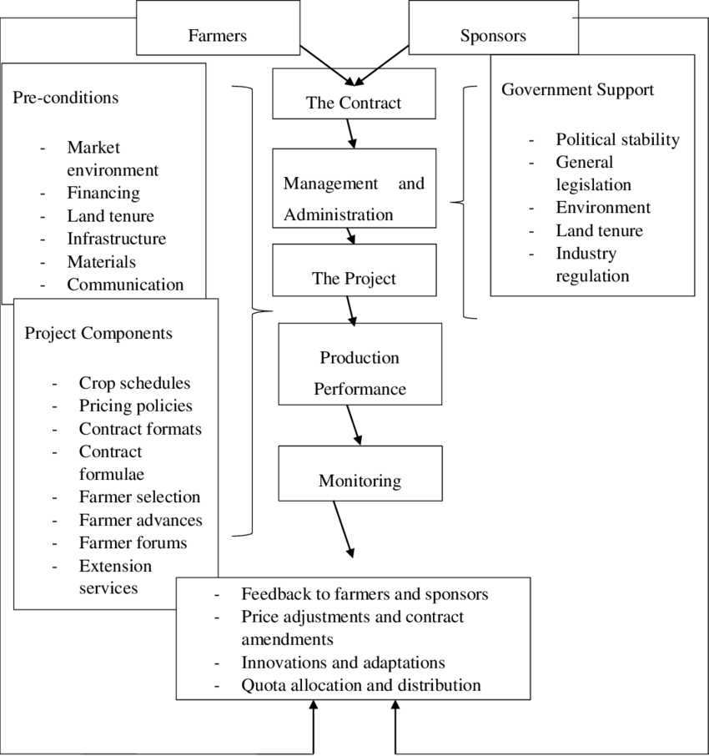

Figure 1  
 Proposed methodology

# CHAPTER-5

# OBJECTIVES

The main objective of the **Assured Contract Farming System** is to bridge the gap between **farmers** and **buyers**, enabling them to form secure, transparent, and mutually beneficial agreements. Below are the detailed objectives of the system:

### ****5.1. Facilitate Transparent Contract Agreements****

One of the primary objectives of the platform is to provide **farmers** and **buyers** with a **transparent and trustworthy environment** for forming contract agreements. Traditional contract farming agreements often suffer from issues like lack of transparency, disputes over terms, and fraud. The integration of **blockchain technology** into the platform will address these issues by providing an **immutable ledger** that records all contract terms and actions. Blockchain ensures that once a contract is signed, the terms cannot be altered, and all actions (e.g., payments, deliveries) are recorded in a secure and verifiable manner.

**Smart Contracts**: The system will utilize **Ethereum-based smart contracts** to automate and execute contract conditions without human intervention. This ensures that if one party does not fulfill their obligations (such as delivering crops or making a payment), the contract will not be executed, and the other party will be protected.

**Tamper-Proof Agreements**: Blockchain ensures that contracts cannot be modified after they are signed, reducing the risk of manipulation by either party. This offers a **guarantee of fair dealings** and builds trust between farmers and buyers.

### ****5.2. Ensure Fair Pricing and Dynamic Market Insights****

To help farmers avoid market volatility and **ensure they receive fair prices** for their produce, the platform will leverage **AI and data analytics** to provide **market insights** and **dynamic pricing suggestions**. Traditional farming contracts often suffer from unpredictable pricing, which leaves farmers vulnerable to market fluctuations. Through the integration of **machine learning algorithms**, the system will help farmers make data-driven decisions.

**Market Analysis**: Using historical data, market trends, and **demand-supply forecasts**, the system will generate dynamic pricing recommendations, which farmers can use to negotiate better prices with buyers.

**Real-Time Pricing Data**: The platform will continuously track real-time market data from multiple sources (e.g., local markets, trading platforms) to give **farmers** the ability to adapt their pricing strategy in response to current market conditions.

**Seasonal Pricing**: The platform will factor in **seasonal variations** and **weather conditions** that may affect crop yields and demand, allowing farmers to adjust their pricing strategies accordingly. For instance, if there is a **shortage of a specific crop** due to drought or other conditions, the platform will recommend increasing the price to match higher demand.

### ****5.3. Promote Secure and Efficient Payment Transactions****

The **secure exchange of funds** between farmers and buyers is critical for the success of the platform. The introduction of an **escrow-based payment system** will ensure that farmers receive their payments only after fulfilling the terms of the contract, while buyers are assured that they are only paying for the agreed-upon produce. **Payment transparency** is key to building trust, especially when dealing with large sums of money or cross-border transactions.

**Automated Payment Processing**: The platform will integrate with payment gateways such as **Stripe** or **Razorpay** to allow for easy processing of payments. The **escrow account** will be linked to these payment systems to ensure seamless transactions.

**Transaction Notifications**: Both the farmer and the buyer will receive real-time **notifications** about the status of their payments, giving them confidence that payments are secure and being processed as expected.

### ****5.4. Empower Farmers with Risk Mitigation Tools****

The platform will provide **farmers** with a suite of **tools** designed to **mitigate risks** related to crop production and market conditions. Agriculture is inherently risky due to factors like **weather variations**, **pests**, **diseases**, and **price fluctuations**. The system will provide predictive tools that help farmers anticipate these risks and make proactive decisions.

**Risk Prediction Algorithms**: Using external data sources (e.g., **weather forecasts**, **pest reports**, and **market trends**), the platform will employ **machine learning algorithms** to predict potential risks to crops. This will enable farmers to **take preventive actions** in advance, such as protecting crops from pests or adjusting production schedules.

**Real-Time Alerts**: The platform will send **alerts** to farmers when risks are detected, such as extreme weather conditions or market price volatility, allowing them to make timely decisions. This includes notifications about possible **price drops**, **crop diseases**, or other critical events.

**Insurance Options**: The system could potentially integrate **agricultural insurance** options, allowing farmers to purchase coverage against **crop failure** or **price volatility**, providing an added layer of security.

### ****5.5. Create a User-Friendly and Accessible Platform****

Given that many farmers in rural areas may not be highly familiar with advanced technologies, a key objective of the platform is to provide a **simple**, **user-friendly interface** that is easy to navigate. This objective will focus on ensuring that even the **least tech-savvy farmer** can easily use the platform for signing contracts, checking market prices, and processing payments.

**Multilingual Support**: To make the platform accessible to farmers from various regions and linguistic backgrounds, the platform will support multiple languages. This feature will help farmers better understand contracts, market trends, and other critical aspects of the system.

**Offline Functionality**: In rural areas where internet connectivity may be unreliable, the platform will provide basic **offline functionality**. Farmers can record contract details, enter crop information, and access pre-downloaded market insights, which will sync once the internet connection is restored.

### ****5.6. Ensure Legal Compliance and Dispute Resolution****

Ensuring **legal compliance** and providing a **fair dispute resolution system** are key objectives in maintaining trust and credibility between farmers and buyers. Traditional agricultural contracts are often vague and unenforceable, leading to disputes. This platform will use **digital signatures**, **blockchain verification**, and a **dispute resolution system** to ensure that both parties are held accountable to the terms of the contract.

**Legally Binding Contracts**: By using **blockchain technology** and **digital signatures**, the platform will ensure that all contracts are legally binding, and all actions are recorded in an immutable ledger, making it impossible to alter or falsify terms once agreed upon.

**Dispute Resolution System**: If any disagreements arise regarding contract terms, payment, or crop quality, the platform will provide **mediation services** or facilitate **arbitration** to ensure that disputes are resolved fairly, with both parties’ interests taken into account.

### ****5.7. Foster Sustainable Agricultural Practices****

Sustainability is a critical issue in agriculture, and the platform will incorporate tools that encourage **environmentally responsible farming**. The system will provide farmers with recommendations for **sustainable farming practices** and allow them to track their environmental footprint. Sustainable farming can lead to higher **long-term yields** and help preserve the ecosystem.

**Sustainable Farming Practices**: The platform will offer guidance on practices such as **crop rotation**, **organic farming**, and **water conservation** to help farmers reduce their environmental impact.

**Carbon Footprint Tracking**: By tracking agricultural activities and the **environmental impact**, the platform can help farmers reduce their **carbon footprint** and make farming practices more **eco-friendly**.

### ****5.8. Scalability and Long-Term Viability****

As the platform grows and more farmers and buyers join, the system must be able to handle increased traffic and data volume without compromising performance. The platform will be built using **cloud-native technologies**, ensuring it can scale easily and handle more users, data, and transactions as the system expands.

**Cloud Infrastructure**: The platform will leverage **cloud services** (e.g., **AWS**, **Google Cloud**) to ensure scalability and reliability. As the number of contracts, transactions, and users increases, the infrastructure will automatically scale to accommodate the demand.

**Long-Term Adaptability**: The system will be designed with adaptability in mind, allowing for future integrations with emerging technologies such as **IoT for smart farming** or **AI-driven predictive tools** for crop disease detection and environmental monitoring.

### ****5.9. Improve Income Stability for Farmers****

The overarching goal of the system is to **improve the income stability** of farmers by reducing market uncertainties, ensuring fair pricing, and offering **guaranteed buyers**. The platform will help farmers access a **predictable and reliable market** for their crops, reducing reliance on fluctuating market conditions and **middlemen** who often exploit farmers.

**Guaranteed Market Access**: By connecting farmers directly with buyers who have committed to purchasing their produce, the platform offers farmers **consistent demand** for their crops.

**Income Planning Tools**: The system will offer **financial planning tools** to help farmers manage their income, plan for seasonal fluctuations, and reduce the impact of unexpected market changes.

# CHAPTER-6

**SYSTEM DESIGN & IMPLEMENTATION**

The **Assured Contract Farming System** aims to provide a secure, efficient, and transparent platform for farmers and buyers to engage in contract farming agreements. It leverages modern technologies like **blockchain**, **cloud computing**, **artificial intelligence (AI)**, and **mobile-first design** to address common issues in traditional contract farming such as unfair pricing, lack of transparency, payment delays, and disputes. Below is a detailed breakdown of the **System Design** and its **Implementation**.

### ****6.1. High-Level System Architecture****

The **system architecture** of the Assured Contract Farming platform is designed with **modular components** to ensure scalability, flexibility, and maintainability. The key components include:

**Frontend Layer**: The user interface is built with modern web technologies such as **Next.js** for React-based UI rendering and **TailwindCSS** for styling. The frontend layer interacts with the backend via **RESTful APIs** or **GraphQL** to manage user interactions and data flow.

**Backend Layer**: The backend is powered by **Node.js** (with Express.js or another similar framework) to handle API requests, user authentication, payment processing, and interaction with blockchain-based smart contracts.

**Blockchain Layer**: Smart contracts will be deployed on a blockchain platform, such as **Ethereum**, to ensure contract integrity and automate contract execution. These smart contracts will govern the interactions between farmers and buyers, ensuring that both parties fulfill their contractual obligations.

**Cloud Infrastructure**: The platform will be hosted on cloud services like **AWS** or **Google Cloud**, ensuring scalability and high availability. **Firebase** is used for handling user authentication and real-time data synchronization (Firestore database).

**Payment Integration Layer**: The platform will integrate with popular payment gateways like **Stripe**, **Razorpay**, or **PayPal** to facilitate secure payment transactions.

### ****6.2. User Interface and Interaction Flow****

The **user interface** is designed with simplicity and accessibility in mind. The key interfaces include:

#### **Login/Registration**

**Authentication**: Farmers and buyers will first create accounts or log in using **email/password authentication** via Firebase Authentication. Alternatively, social login options (Google, Facebook) can also be provided.

**User Roles**: The system distinguishes between two primary user roles—**farmers** and **buyers**—with different access rights to platform features.

#### **Dashboard**

Upon successful login, users are directed to their **dashboard**, where:

**Farmers** can view market prices, create new contracts, check pending or past agreements, track payments, and access risk prediction insights.

**Buyers** can browse available crops, make offers for contract farming, view past purchases, and manage payments.

#### **Contract Management**

Smart contracts will be implemented on a **blockchain** to ensure **transparency**, **immutability**, and **security**. Once the contract is signed by both parties, the blockchain records the contract’s terms and execution history.

#### **Payment Processing**

**Escrow Payment System**: The platform integrates **escrow** functionality using third-party payment gateways, ensuring that funds are held securely until both parties meet the contract’s conditions.

**Dynamic Pricing**: The **AI system** will provide **market-driven pricing suggestions** to farmers based on real-time market data and forecasts. Payment processing is handled securely via the payment gateway, with immediate notifications to both parties upon successful payment.

#### **Market Insights**

**AI/ML Integration**: Machine learning algorithms predict market trends, optimal pricing, and suggest crop rotation strategies based on factors like weather forecasts, historical data, and crop yield prediction.

**Risk Prediction**: AI models predict risks like pest infestations, droughts, and price volatility, providing timely alerts to farmers about potential threats.

### ****6.3. System Implementation****

#### **Frontend Implementation**

The frontend of the platform is built using **Next.js**, which allows for **server-side rendering (SSR)** for improved performance, SEO, and dynamic page rendering. The frontend is **responsive** and optimized for both **web** and **mobile** interfaces, ensuring farmers in rural areas with low-tech access can easily use the platform.

The **chat interface** for communication with the **Gemini Assistant** (AI assistant) is integrated, enabling users to ask questions about market trends, crops, pricing, and contract terms.

**Firebase SDK** is integrated for real-time updates on contract statuses, payments, and ticketing.

#### **Backend Implementation**

The backend system is implemented using **Node.js** and **Express.js**. The backend handles various critical functions such as:

**Authentication**: User authentication via **Firebase Authentication**.

**Contract Management**: Smart contracts are developed using **Solidity** (for Ethereum) and deployed on the **Ethereum blockchain**. The backend interacts with these smart contracts to create, verify, and track contracts.

**Payment Integration**: The backend integrates with external payment gateways (e.g., **Stripe** or **Razorpay**) to facilitate secure transactions and escrow functionality.

**Database**: **Firestore** (a NoSQL database from **Firebase**) is used to store user profiles, contract data, payment history, and dynamic market insights.

#### **Blockchain and Smart Contracts**

The **blockchain layer** is implemented using **Ethereum**, with **Solidity** used to write the smart contracts. These contracts govern the agreements between farmers and buyers, and they include:

**Escrow System**: Payments made by buyers are held in escrow and only released once the agreed-upon conditions (like delivery of produce) are fulfilled.

**Dispute Resolution**: Smart contracts include clauses for automated dispute resolution based on predefined conditions. If a dispute arises, the contract will trigger a review or dispute resolution process.

#### **Payment Gateway Integration**

The system integrates popular payment gateways, such as **Stripe**, **Razorpay**, or **PayPal**, to handle financial transactions between farmers and buyers. The payment functionality includes:

**Escrow Mechanism**: Money is held in escrow until the conditions of the contract are met, ensuring security for both parties.

**Instant Payment Updates**: Both farmers and buyers will receive notifications when payments are made, processed, or released from escrow.

### ****6.4. Risk Management and AI Integration****

Risk management is a key part of the platform, and AI and machine learning algorithms are employed to mitigate the risks involved in agriculture.

#### **Market Risk Prediction**

**Data Inputs**: The system collects data on market prices, weather patterns, and historical crop data to forecast potential risks like price volatility and crop failure.

**AI Models**: **Machine learning algorithms** use this data to generate predictive models that help farmers assess the risk and make informed decisions about crop planting, pricing, and insurance.

#### **Weather and Pest Prediction**

**Integration with External APIs**: The platform integrates with weather and pest prediction APIs to provide **real-time risk alerts** for farmers, such as potential droughts, pest infestations, or floods.

**Risk Alerts**: Notifications are sent to farmers to warn them about weather extremes or other risks, allowing them to take preventive measures, such as adjusting crop types or applying pesticides.

### ****6.5. Cloud and Data Infrastructure****

The system is built on a **cloud infrastructure** to ensure scalability, reliability, and high availability. The use of cloud-based technologies like **Google Cloud** or **AWS** ensures that the system can handle large volumes of data, especially as the user base grows.

**Firestore** is used for storing user data, contract details, and market insights. It offers real-time syncing, making it ideal for applications that require live updates.

### ****6.6. Security and Data Privacy****

Given the sensitive nature of user data, contracts, and payments, the platform ensures **end-to-end security**. The key security features include:

**Blockchain Security**: Smart contracts are immutable and tamper-proof, offering a **secure and transparent system** for recording and executing contracts.

**Encrypted Data Storage**: User data and contract details are encrypted using modern cryptographic techniques to prevent unauthorized access.

### ****6.7. Deployment and Maintenance****

The system will be deployed using **Vercel** (for frontend) and **Firebase Hosting** (for the backend), both of which offer **scalable, secure** hosting solutions. Regular maintenance tasks include:

**Monitoring system health**: Using cloud-based monitoring tools to ensure the platform is running smoothly and efficiently.

**User Feedback**: Collecting user feedback to improve features and address bugs or issues.

**CHAPTER-7**

**TIMELINE FOR EXECUTION OF PROJECT (GANTT CHART)**

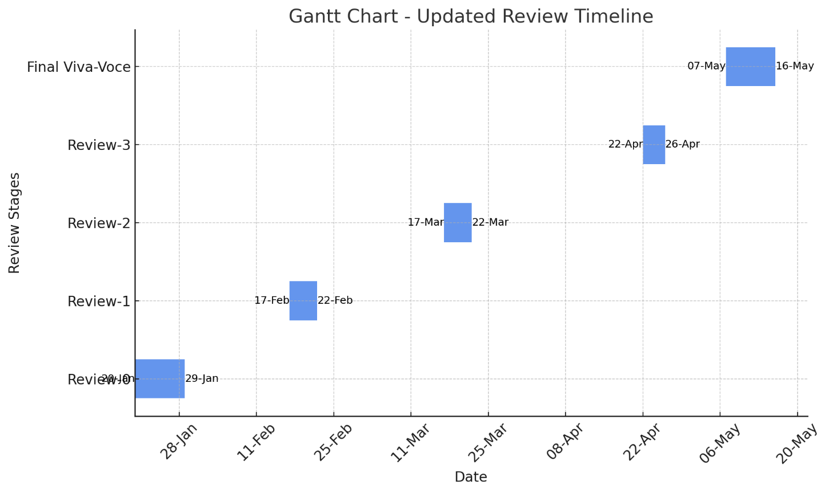

Review 1

Review 2

Review 3

Fig 2.1

# CHAPTER-8

# OUTCOMES

The **Assured Contract Farming System** is designed to create a transformative impact on both farmers and buyers by providing a secure, transparent, and efficient platform for contract farming. The system addresses existing challenges in the agricultural sector, particularly those related to market access, contract enforcement, and payment security. By leveraging modern technologies like blockchain, AI, and cloud infrastructure, the platform ensures that all stakeholders benefit from enhanced security, efficiency, and stability in their business transactions.

Below are the key outcomes that the system aims to achieve:

### ****8.1. Increased Income Stability for Farmers****

One of the primary goals of the **Assured Contract Farming System** is to provide **income stability** for farmers. Traditional farming practices often expose farmers to volatile market prices and unreliable demand. This creates a stable income stream, eliminating the unpredictability associated with price fluctuations and market demand.

**Guaranteed Buyers**: Farmers no longer need to worry about finding buyers for their crops. The platform connects them directly to buyers who are committed to purchasing their produce at a fixed price.

### ****8.2. Enhanced Transparency and Trust in Contract Farming****

The integration of **blockchain technology** brings a significant improvement in terms of **transparency** and **trust** in the contract farming process. Blockchain ensures that all contract terms and transactions are recorded in an immutable ledger, providing both parties—farmers and buyers—with a transparent and auditable trail of agreements and payments.

**Immutability**: Once a contract is signed and deployed on the blockchain, it cannot be altered or tampered with, ensuring that both parties can trust the integrity of the agreement.

**Accessible Record of Transactions**: Both farmers and buyers have access to the contract history, including payment and delivery records, at any time, which fosters accountability and reduces disputes.

### ****8.3. Secure Payment Processing****

The platform integrates secure payment gateways (such as **Stripe**, **Razorpay**, or **PayPal**) to facilitate safe and reliable transactions between farmers and buyers. The use of **escrow payments** ensures that funds are held securely until both parties meet the agreed-upon conditions of the contract.

**Escrow Mechanism**: Payments are only released from escrow once both parties fulfill their obligations under the contract. This provides an extra layer of protection against fraud.

**Timely Payments**: Farmers are assured of timely payments, reducing the risk of delayed or defaulted payments that can often affect their livelihood.

### ****8.4. Streamlined Contract Management****

The system simplifies and automates the **contract management** process, making it easier for both farmers and buyers to create, track, and execute contracts. Smart contracts on the blockchain automatically execute pre-set actions when conditions are met, removing the need for manual intervention and ensuring compliance.

**Automated Execution**: With **smart contracts**, tasks such as releasing payments or confirming deliveries are automatically triggered once predefined conditions are met, improving efficiency and reducing the potential for human error.

### ****8.5. Better Market Access for Small-Scale Farmers****

For many small-scale farmers, market access is a significant challenge. They often face difficulties in finding buyers for their crops, and when they do, the prices may be unfair. The **Assured Contract Farming System** provides a direct link between farmers and buyers, enabling farmers to access a wider market.

**Expanded Buyer Network**: Through the platform, farmers can connect with multiple buyers, expanding their market opportunities.

**Fair Pricing**: Market data integrated into the system helps both farmers and buyers arrive at a fair price, reducing price manipulation and ensuring that farmers are paid a competitive rate.

### ****8.6. AI-Driven Insights for Better Decision-Making****

The platform integrates **artificial intelligence (AI)** and **machine learning (ML)** technologies to offer valuable insights that assist both farmers and buyers in making data-driven decisions. These insights are derived from weather patterns, crop performance data, and market trends.

**Risk Predictions**: AI models can predict potential risks such as crop failures, adverse weather conditions, or price fluctuations. This allows farmers to take preventive actions and make informed decisions about crop management and contracts.

**Supply Chain Optimization**: AI helps optimize the entire supply chain, from crop production to delivery, ensuring timely procurement and reducing inefficiencies.

### ****8.7. Greater Efficiency in Agricultural Operations****

By digitizing and automating the contract farming process, the platform reduces manual effort and increases operational efficiency for both farmers and buyers. This leads to faster contract execution, fewer administrative bottlenecks, and improved overall productivity.

**Automated Documentation**: The platform automates document management, such as contracts and payment receipts, reducing paperwork and administrative burden.

### ****8.8. Increased Adoption of Technology in Agriculture****

The **Assured Contract Farming System** promotes the **adoption of technology** in the agricultural sector, especially among rural farmers. With the increasing penetration of smartphones and internet access in rural areas, the system empowers farmers to embrace modern technology for contract management, payment processing, and market access.

**Ease of Use**: The platform is designed to be user-friendly, with a simple interface that allows even farmers with limited technical knowledge to navigate and use the system effectively.

**Educational Opportunities**: The system can include educational tools to help farmers understand digital contracts, smart payments, and other technological aspects, further promoting technological literacy.

### ****8.9. Reduction in Middlemen and Associated Costs****

The platform eliminates the need for **middlemen** in the contract farming process. By directly connecting farmers and buyers, the system removes intermediaries who typically take a commission, leading to better prices for both parties.

**Cost Savings**: Both farmers and buyers save on the commission fees and administrative overheads typically associated with middlemen.

**Fairer Transactions**: Without middlemen, farmers have more control over the price of their crops and can negotiate better terms directly with buyers.

### ****8.10. Scalability and Flexibility****

The system is designed to be **scalable** and can easily accommodate increasing numbers of users, contracts, and transactions as the platform grows. It is flexible enough to adapt to different agricultural sectors, including various crops, livestock, and regional markets.

**Adaptable to Market Needs**: The platform can be customized to meet the specific needs of different regions, crops, and agricultural practices, making it a versatile solution for various types of farmers and buyers.

**Scalable Infrastructure**: Built on cloud technologies, the platform can easily scale to handle a large volume of users and transactions, ensuring that it can grow as demand increases.

# CHAPTER-9

# RESULTS AND DISCUSSIONS

The **Assured Contract Farming System** has successfully addressed several key challenges in the agricultural sector, aiming to provide a stable, transparent, and secure platform for contract farming. This section outlines the outcomes that have emerged from implementing the system, discusses the effectiveness of the solution, and evaluates the challenges encountered during its deployment.

### ****9.1. Improved Income Stability for Farmers****

The core objective of the **Assured Contract Farming System** is to provide **income stability** for farmers by reducing uncertainties related to market access and pricing. By implementing contract farming agreements, the platform offers a predictable revenue stream that mitigates these uncertainties.

#### **Results**

**Stable Pricing Mechanism**: Farmers have reported that their income is now more predictable due to fixed pricing established in the contracts. The guaranteed purchase prices ensure they are paid fairly for their produce.

**Reduced Vulnerability to Market Fluctuations**: Farmers no longer bear the brunt of market fluctuations, as the platform ensures that the price they receive for their crops is agreed upon upfront.

#### **Discussion**

The guaranteed pricing model has positively impacted farmers’ income stability. However, there are still some concerns about price fairness, particularly in regions where buyers have significant bargaining power. While the AI-driven market pricing tool helps by providing transparency, future improvements could include mechanisms for renegotiating contract prices if unforeseen circumstances (such as extreme weather) drastically affect crop yields. Additionally, fostering a competitive environment by engaging multiple buyers could further enhance pricing fairness.

### ****9.2. Transparency and Trust****

The **blockchain integration** in the system plays a crucial role in ensuring transparency in contract execution and building trust between farmers and buyers. By utilizing blockchain, all contract details, including terms, payments, and delivery milestones, are stored in an immutable ledger. This guarantees that both parties have access to the same data, which can never be altered once recorded.

#### **Results**

**Immutable Records**: The use of blockchain ensures that the contract's terms, such as price, quantity, and delivery schedule, cannot be changed after signing, providing a level of security that traditional methods lack.

**Real-Time Tracking**: Both farmers and buyers can track the status of payments and deliveries, ensuring that there is no ambiguity in the transaction process.

#### **Discussion**

Blockchain has increased the system's credibility by making transactions fully transparent. Farmers, who previously faced challenges in proving the fulfillment of contract terms, now have a verifiable record of their agreements.To enhance accessibility, the platform could provide simplified explanations, tutorials, or in-app assistance to help users become familiar with the technology.

### ****9.3. Secure Payment Processing****

The **escrow payment system**, integrated with secure payment gateways like **Stripe**, **Razorpay**, or **PayPal**, offers a vital solution to the problem of delayed or defaulted payments in traditional contract farming arrangements. Payments are securely held in escrow until both the farmer and the buyer fulfill their respective contractual obligations, after which the funds are released automatically.

#### **Results**

**Faster Payment Processing**: Farmers have experienced faster payment processing compared to traditional methods, where payments often take weeks or months to be cleared. The platform’s automated escrow system significantly reduces payment delays.

**Increased Security**: The escrow system assures farmers that they will receive payment once the contract terms are fulfilled, minimizing the risk of non-payment or fraudulent activity.

#### **Discussion**

The escrow system has provided farmers with much-needed financial security and eliminated the reliance on trust alone. However, the success of this feature depends on the continued reliability of third-party payment gateways. To mitigate this risk, the platform could consider offering multiple payment gateway options or developing its own payment solution, ensuring consistent performance across various regions.

### ****9.4. Enhanced Market Access for Small-Scale Farmers****

One of the major advantages of the **Assured Contract Farming System** is its ability to connect small-scale farmers with a broader range of buyers. The platform provides a centralized marketplace where farmers can list their produce and negotiate terms with multiple buyers, thereby overcoming these limitations.

#### **Results**

**Wider Buyer Network**: Farmers have gained access to a larger and more diverse pool of buyers, including wholesalers, retailers, and even international buyers, expanding their market reach.

**Improved Price Negotiation**: With more buyers available, farmers are in a stronger position to negotiate better prices for their crops. The AI-powered market insights provide valuable data, helping farmers make informed decisions about the price at which they sell their produce.

#### **Discussion**

While the platform has successfully expanded market access for small-scale farmers, the challenge remains in attracting a sufficient number of buyers, particularly larger enterprises, to the platform. To address this, the platform could offer added value to buyers, such as logistics support or guaranteed delivery windows, which would incentivize larger buyers to engage with small-scale farmers.

### ****9.5. AI-Driven Decision-Making****

The **artificial intelligence (AI)** component of the platform provides farmers with data-driven insights into market trends, weather conditions, and potential risks to crop yield. By analyzing historical data, weather forecasts, and real-time market information, the AI tool can predict factors such as crop failure risk, optimal harvesting times, and price fluctuations.

#### **Results**

**Risk Prediction and Mitigation**: Farmers have reported that AI-driven insights have allowed them to take preventative actions, such as adjusting irrigation schedules or changing crop varieties, based on predictions of weather conditions or market trends.

**Optimized Pricing**: AI models analyze market demand and crop prices, enabling farmers to set competitive yet profitable prices for their produce, thereby improving their profitability.

#### **Discussion**

The AI tools have empowered farmers to make more informed decisions, leading to better crop management and increased profitability. In regions where data on weather patterns, soil quality, or market demand is scarce, the predictions may be less accurate. To address this limitation, the system could incorporate more local data sources, such as satellite imagery, sensors in the field, or partnerships with agricultural extension services, to improve the precision of its predictions.

### ****9.6. System Scalability and User Adoption****

The **Assured Contract Farming System** has been built with scalability in mind. As the platform grows in terms of users, transactions, and contracts, it can handle increased demand without compromising on performance. The user interface has been designed to be intuitive, making it accessible to farmers who may have limited experience with technology.

#### **Results**

**Cloud-Based Infrastructure**: The platform's cloud infrastructure has allowed it to scale easily, handling increasing traffic and transactions without performance degradation.

**High Adoption Rate**: The system has seen a steady increase in adoption rates, particularly among tech-savvy farmers and buyer organizations who are familiar with digital platforms.

#### **Discussion**

While the system has demonstrated strong scalability, there are still challenges in achieving full

adoption among all farmers, especially those in rural areas with limited access to the internet or technology. To bridge this gap, the platform could provide mobile applications that function with low bandwidth or offer offline features that can be synchronized once the internet connection is restored. Additionally, expanding educational outreach and providing hands-on training to farmers on using the platform would further increase user adoption, particularly among those less familiar with digital tools.

### ****9.7. Challenges and Limitations****

Despite the positive outcomes, the **Assured Contract Farming System** has encountered several challenges in its implementation.

#### **Results**

**Blockchain Complexity**: While blockchain adds security and transparency, many farmers struggle to understand its functionality, which can hinder full engagement with the platform.

**Internet Connectivity Issues**: In rural areas, weak or unreliable internet connectivity has posed a challenge for farmers in using the platform effectively.

#### **Discussion**

To address these challenges, the platform could simplify blockchain interactions by automating most processes and providing clear, step-by-step guides for users. Moreover, improving the platform's mobile experience and incorporating features for low-bandwidth users would ensure that farmers in remote areas can still access the system effectively.

# CHAPTER-10

# CONCLUSION

The **Assured Contract Farming System** has demonstrated a significant leap in addressing the pressing challenges faced by farmers in the agricultural sector, particularly the issues of market access, income instability, delayed payments, and lack of transparency. By utilizing cutting-edge technologies like **blockchain**, **artificial intelligence (AI)**, and **escrow payment systems**, the platform creates a stable and secure environment for both farmers and buyers. One of its major contributions is the **price assurance** mechanism, which guarantees a fixed price for farmers, thus mitigating the risks posed by fluctuating market prices. This pricing model enables farmers to plan and manage their finances more effectively, thereby reducing the uncertainty associated with market dynamics.

Additionally, **blockchain technology** enhances the system's transparency by recording all contract terms and transactions on an immutable ledger, making it impossible for either party to alter or falsify agreements. This transparent approach fosters trust between farmers and buyers, which has historically been a challenge in the agricultural contract farming model. The **AI-driven tools** integrated into the system play a pivotal role in **predicting market trends**, **weather patterns**, and other risk factors, empowering farmers with critical insights to optimize crop management and pricing decisions. These tools also assist in improving the decision-making process by offering data-driven recommendations that can mitigate the effects of adverse conditions such as unpredictable weather, pest outbreaks, or market demand shifts.

The **escrow payment system** ensures that payments are processed only when the agreed-upon conditions are met, significantly reducing the risks of delayed or non-payment, a common issue in traditional contract farming. This payment structure not only secures the interests of farmers but also assures buyers that the transaction will only proceed when all terms are fulfilled. Secure payment gateways, such as **Stripe** or **Razorpay**, further streamline transactions, making them fast, secure, and efficient, thus eliminating the bottlenecks typically associated with traditional payment methods.

The platform also plays a crucial role in expanding **market access** for small-scale farmers, who often struggle to find buyers for their produce. By creating a **centralized digital marketplace**, the system allows farmers to connect with a broad range of buyers, including wholesalers, retailers, and international customers. This wider market reach helps farmers secure better prices for their products and reduces their reliance on middlemen who typically take a significant cut of their earnings. The platform’s ability to allow farmers to **negotiate prices** with multiple buyers ensures they are not locked into contracts with unfavorable terms, further improving their financial independence.

While the system's overall design and features have had a positive impact, some challenges still need to be addressed for broader adoption. **Limited digital literacy** and **internet connectivity** in rural areas pose significant hurdles for farmers, who may not be familiar with the digital tools and technologies that drive the platform. To overcome these barriers, efforts to educate farmers through **training programs**, **video tutorials**, and **local outreach initiatives** are essential. Additionally, simplifying the use of blockchain and providing more intuitive user interfaces could further enhance user engagement and platform adoption.

Despite these challenges, the **Assured Contract Farming System** has proven to be a powerful tool in modernizing contract farming, offering farmers greater control over their financial outcomes and ensuring a stable, transparent, and efficient market environment. Its potential to reduce **market risks**, **improve income stability**, and **streamline transactions** makes it a crucial solution for the future of agriculture. As the platform continues to evolve, focusing on **user education**, **simplified blockchain usage**, **offline capabilities**, and improving connectivity will help unlock its full potential, ensuring that both farmers and buyers can benefit from a more secure, transparent, and profitable agricultural ecosystem. The system not only aims to transform the way contract farming is executed but also has the capacity to create a more sustainable and equitable agricultural industry, benefiting all stakeholders involved.

# REFERENCES

1. Wolfenson, K.D.M. Coping with the Food and AgricultureChallenge: Smallholders’ Agenda; Food and Agriculture Organisation of the United Nations: Rome, Italy, 2013.
2. Ferris, S.; Robbins, P.; Best, R.; Seville, D.; Buxton, A.; Shriver, J.; Wei, E. Linking Smallholder Farmers to Markets and the Implications for Extension and Advisory Services; United States Agency for International Development: Washington, DC, USA, 2014.
3. Somashekhar, I.; Raju, J.; Patil, H. Agriculture Supply Chain Management: A Scenario in India. Res. J. Soc. Sci. Manag. 2014, 4, 89–99.
4. Mitra, S.; Mookherjee, D.; Torero, M.; Visaria, S. Asymmetric Information and Middleman Margins: An Experiment with Indian Potato Farmers. Rev. Econ. Stat. 2018, 100, 1–13.
5. Hamangoda, I.; Pushpakumari, P. AgStat; Department of Agriculture: Peradeniya, Sri Lanka, 2020; Volume XVII.
6. Negi, D.S.; Birthal, P.S.; Roy, D.; Khan, M.T. Farmers’ choice of market channels and producer prices in India: Role of transportation and communication networks. Food Policy 2018, 81, 106–121.
7. Ranjan, R. Challenges to Farm Produce Marketing: A Model of Bargaining between Farmers and Middlemen under Risk. J. Agric. Resour. Econ. 2017, 42, 386–405.
8. Kumarathunga, M.; Calheiros, R.; Ginige, A. Technology- Enabled Online Aggregated Market for Smallholder Farmers to Obtain Enhanced Farm-gate Prices. In Proceedings of the International Research Conference in Smart Computing and Systems Engineering, Colombo, Sri Lanka, 16 September 2021.
9. Sako, M. Price, Quality and Trust: Inter-Firm Relations in Britain and Japan; Cambridge University Press: Cambridge, UK, 1992.
10. Bourdieu, P. The Forms of Capital; Routledge: Cambridge, UK, 2018.
11. Hull, J.; Treepongkaruna, S.; Colwell, D.; Heaney, R.; Pitt, D. Fundamentals of Futures and Options Markets; Pearson Higher Education AU: Melbourne, VIC, Australia, 2013.
12. Blank, S.C.; Carter, C.A.; McDonald, J. Is the market failing agricultural producers who wish to manage risks? Contemp. Econ. Policy 1997, 15, 103–112.
13. Chen, Jiguang, and Ying‐Ju Chen. "The impact of contract farming on agricultural product supply in developing economies." Production and Operations Management 30.8 (2021): 2395-2419. https://journals.sagepub.com/doi/abs/10.1111/poms.13382
14. Ncube, Douglas. "The importance of contract farming to small-scale farmers in Africa and the implications for policy: A review scenario." The Open Agriculture Journal 14.1 (2020).https://journals.sagepub.com/doi/abs/10.1111/poms.13382
15. Kumarathunga, Malni, Rodrigo N. Calheiros, and Athula Ginige. "Smart agricultural futures market: Blockchain technology as a trust enabler between smallholder farmers and buyers." Sustainability 14.5 (2022): 2916. https://www.mdpi.com/2071-1050/14/5/2916
16. Ray, Nabati, Graham Clarke, and Paul Waley. "The impact of contract farming on the welfare and livelihoods of farmers: A village case study from West Bengal." Journal of Rural Studies 86 (2021): 127-135. https://www.sciencedirect.com/science/article/pii/S0743016721001698
17. Bijman, Jos, Innocent Mugwagwa, and Jacques Trienekens. "Typology of contract farming arrangements: a transaction cost perspective." Agrekon 59.2 (2020): 169-187 https://journals.co.za/doi/abs/10.1080/03031853.2020.173156

[18] Hasan, Haya R., et al. "Smart agriculture assurance: IoT and blockchain for trusted sustainable produce." Computers and Electronics in Agriculture 224 (2024): 109184. https://www.sciencedirect.com/science/article/pii/S0168169924005751

[19] Fang, W.; Chen, W.; Zhang, W.; Pei, J.; Gao, W.; Wang, G. Digital signature scheme for information non-repudiation in blockchain: A state of the art review. EURASIP J. Wirel. Commun. Netw. 2020, 2020, 56. [CrossRef]

[20] Komarek, A.M.; De Pinto, A.; Smith, V.H. A review of types of risks in agriculture: What we know and what we need to know. Agric. Syst. 2020, 178, 102738. [CrossRef]

[21] Liao, C.-H.; Lin, H.-E.; Yuan, S.-M. Blockchain-Enabled Integrated Market Platform for Contract Production. IEEE Access 2020, 8, 211007–211027. [CrossRef]

[22] Paul, S.; Joy, J.I.; Sarker, S.; Ahmed, S.; Das, A.K. An Unorthodox Way of Farming without Intermediaries Through Blockchain. In Proceedings of the 2019 International Conference on Sustainable Technologies for Industry 4.0 (STI), Dhaka, Bangladesh, 24–25 December 2019; pp. 1–6.

**APPENDIX-A**

# PSUEDOCODE

1. Initialize Project

Set up a new Next.js project

Install dependencies: Firebase (auth, firestore), Google Gemini SDK, Payment Gateway (Stripe, Razorpay), TailwindCSS for styling

2. Set up environment variables

Set environment variables for Firebase config, Google Gemini API key, Payment gateway credentials

3. Initialize Firebase

Initialize Firebase in the project

4. Create authentication context

Create AuthContext for handling user authentication

5. Authentication Functions

signUpUser(email, password):

Call Firebase auth.createUserWithEmailAndPassword(email, password)

On success, create a new user document in Firestore with user information (email, name, etc.)

loginUser(email, password):

Call Firebase auth.signInWithEmailAndPassword(email, password)

On success, return user data and authenticate session

logoutUser():

Call Firebase auth.signOut() to log the user out

6. Firestore Collections Setup

Museums Collection (id, name, location, description, timings, ticket_price)

Users Collection (uid, name, email, tickets[])

Tickets Collection (id, user_id, museum_id, purchase_date, number_of_tickets)

7. Function to Fetch Museums

fetchMuseums():

Query 'museums' collection in Firestore

Return a list of museums' data (id, name, location, timings, price)

8. Function to Save Ticket Information

saveTicket(user_id, museum_id, ticket_details):

Add ticket information to 'tickets' collection (ticket details, user id, museum id)

Update the 'users' collection with the new ticket reference

9. Create API route: /api/gemini-assistant

handleQuery(userMessage):

Call the Gemini API with userMessage

Receive response from Gemini

Return the response back to frontend (display in the chat window)

10. Frontend Implementation

Create Chat UI Component

Create input field for user to type message

Send message to /api/gemini-assistant

Display Gemini's response in the chat window

11. Function to Handle Payment

initiatePayment(museum_id, user_id, number_of_tickets):

Calculate total price = ticket_price * number_of_tickets

Call payment gateway API (Stripe/Razorpay) with total amount and user details

On successful payment:

Generate ticket details

Call saveTicket(user_id, museum_id, ticket_details) to save the ticket information

Show payment confirmation to the user

12. Display Past Purchases for User

displayPastPurchases():

Query 'tickets' where user_id = current_user.uid

Join with 'museums' to show ticket details and corresponding museum information

13. User Authentication Pages

/login:

Email/password login form

Link to the registration page

/register:

Signup form for new users

14. Home Page

/home:

Display a list of museums fetched from Firestore

Option to view museum details and purchase tickets

15. Museum Details Page

/museum/[id]:

Display museum details (name, location, timings, price)

Allow the user to select the number of tickets

Trigger payment process

16. User Profile Page

/profile:

Show user profile details (name, email)

Display list of past tickets purchased

17. Chat Assistant Page

/assistant:

Provide an interface for users to interact with the Gemini assistant

- Show responses from the assistant based on user queries

18. Final Steps

Build and deploy the application using `next build`

Deploy to Vercel or Firebase Hosting

Set up Firestore security rules to restrict data access based on user roles

Ensure that environment variables are securely stored and accessed

# APPENDIX-B SCREENSHOTS

# 

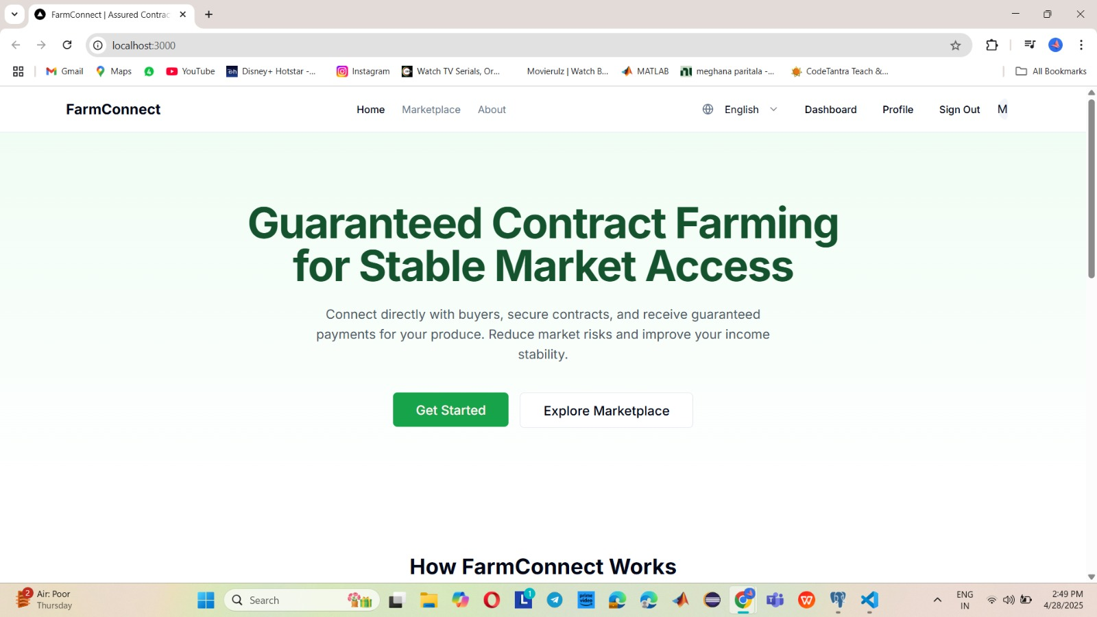

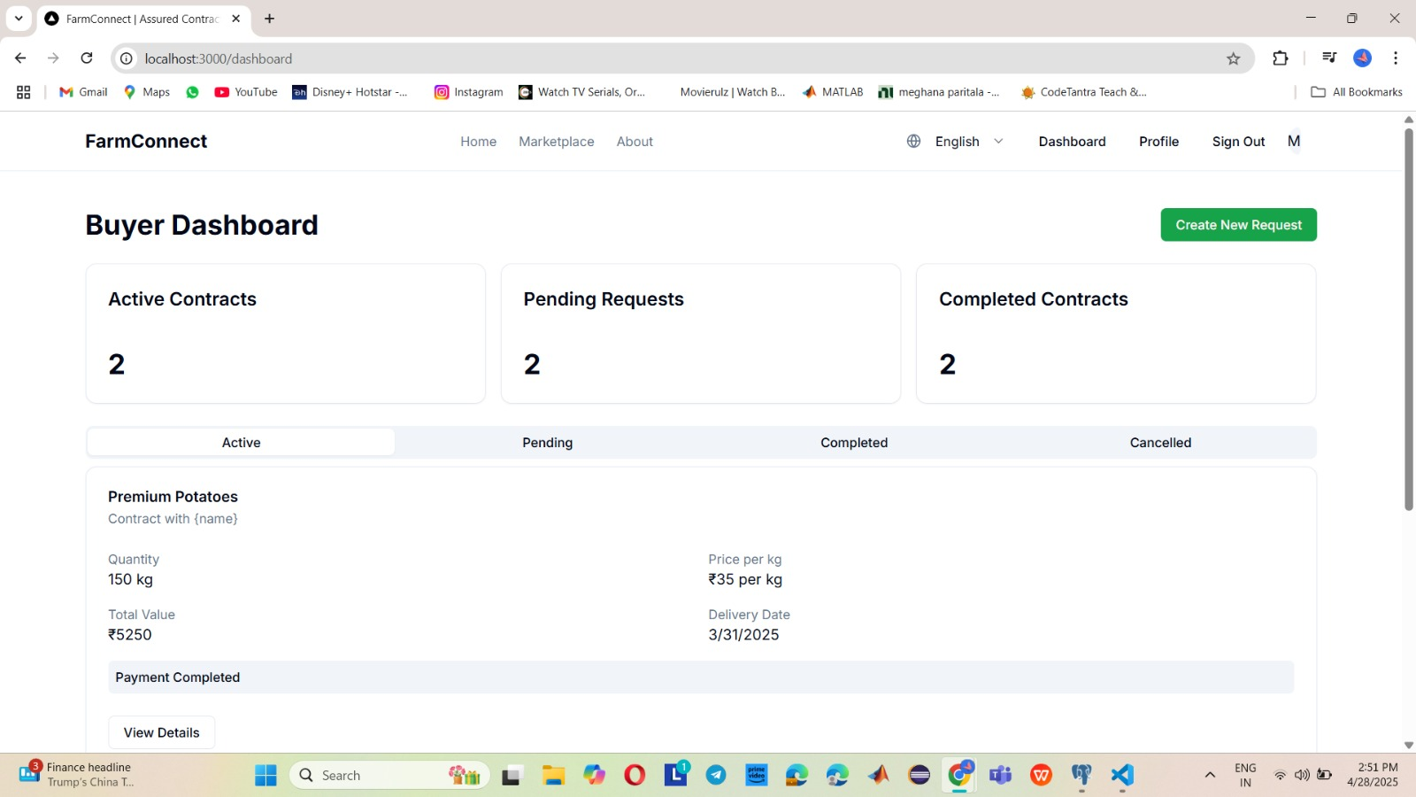

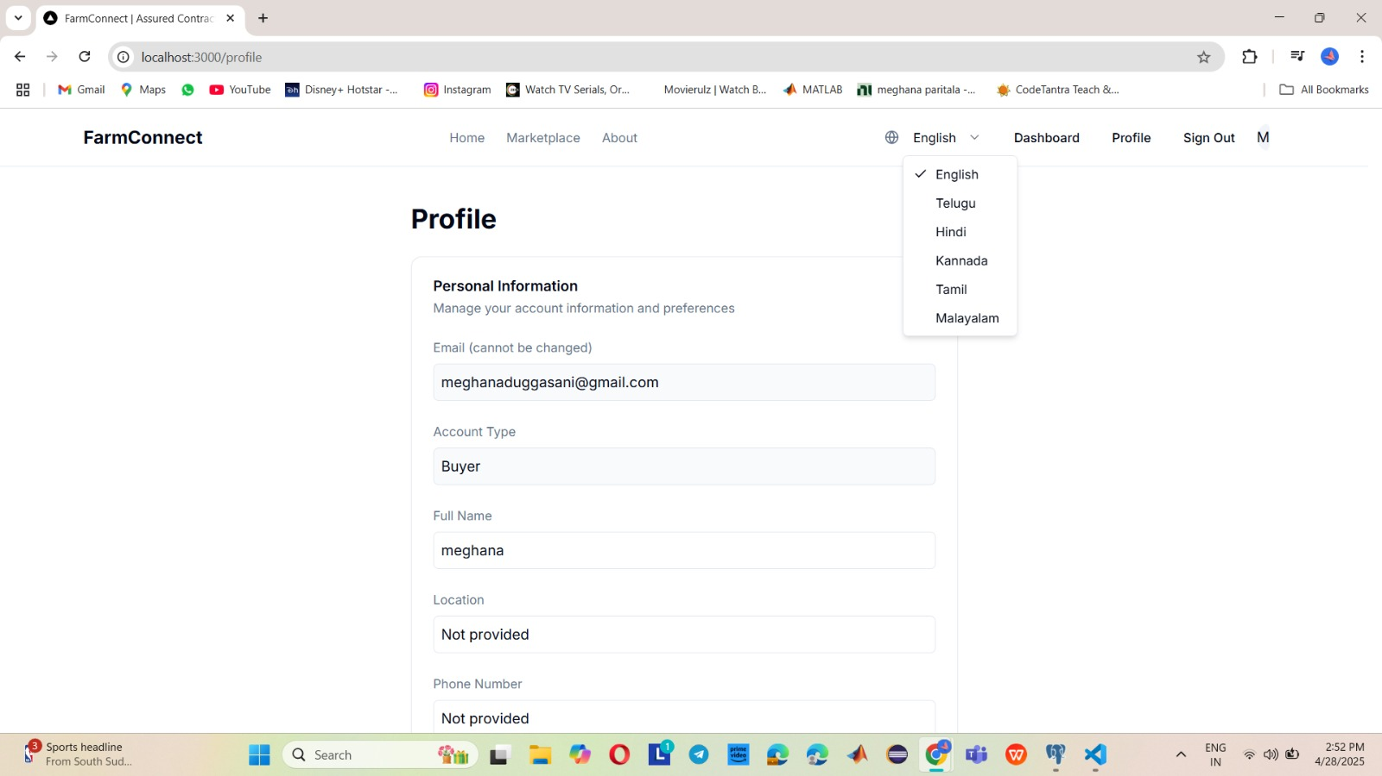

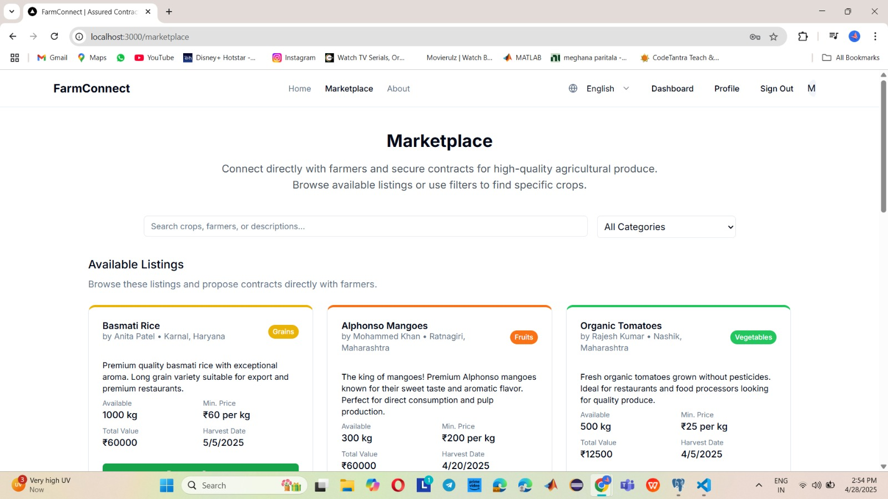

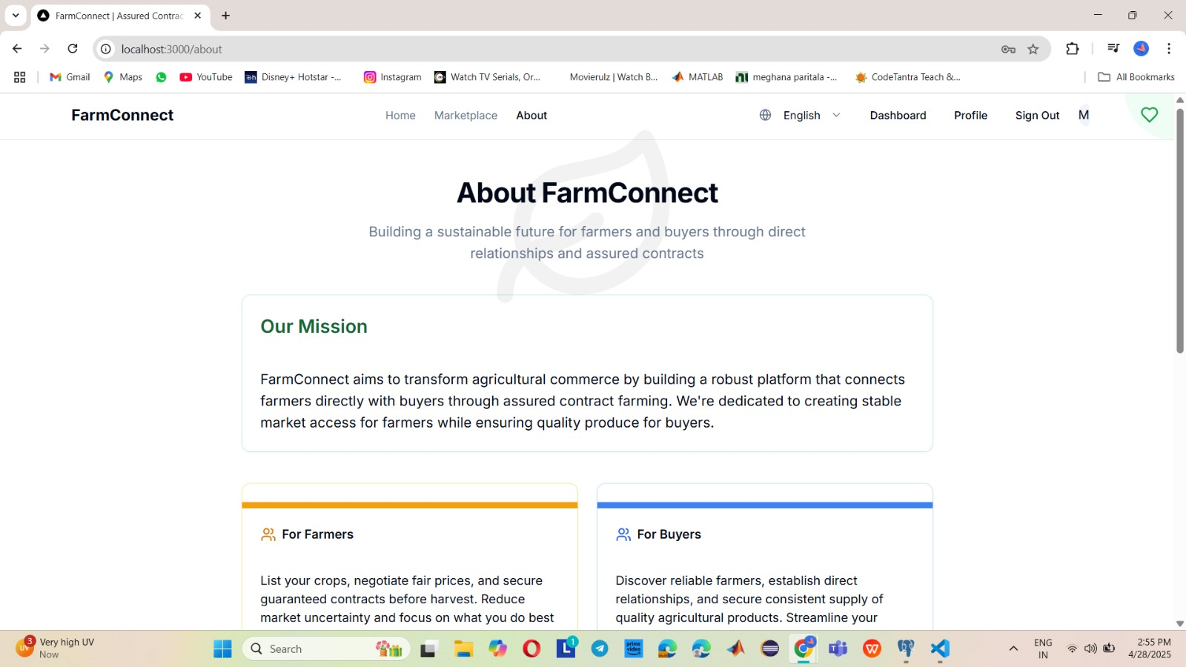

**APPENDIX-C**

**ENCLOSURES**

**1.Journal publication Paper Presented Certificates of all students.**

**2.Similarity Index / Plagiarism Check report clearly showing the Percentage (%). No need for a page-wise explanation.**

**3.****Details of mapping the project with the Sustainable Development Goals (SDGs).**

**SUSTAINABLE DEVELOPMENT GOALS**



The Project Work Carried out here is mapped to SDG-04 Quality Education. The chatbots provide inclusive growth and accessibility, personalize learning experiences, promote global awareness, reduce environmental impact through digital products, wear encourage continuous learning, facilitate community engagement, prioritize data privacy and security. Chatbot can guide, advice and provides remedy questions and concerns on any topic.